STANDARD FORMAT OF “LEHENGA DESCRIPTION”


For Online Selling Products
Design Name: PEHNAVA-B
Product Colours NO.: B3

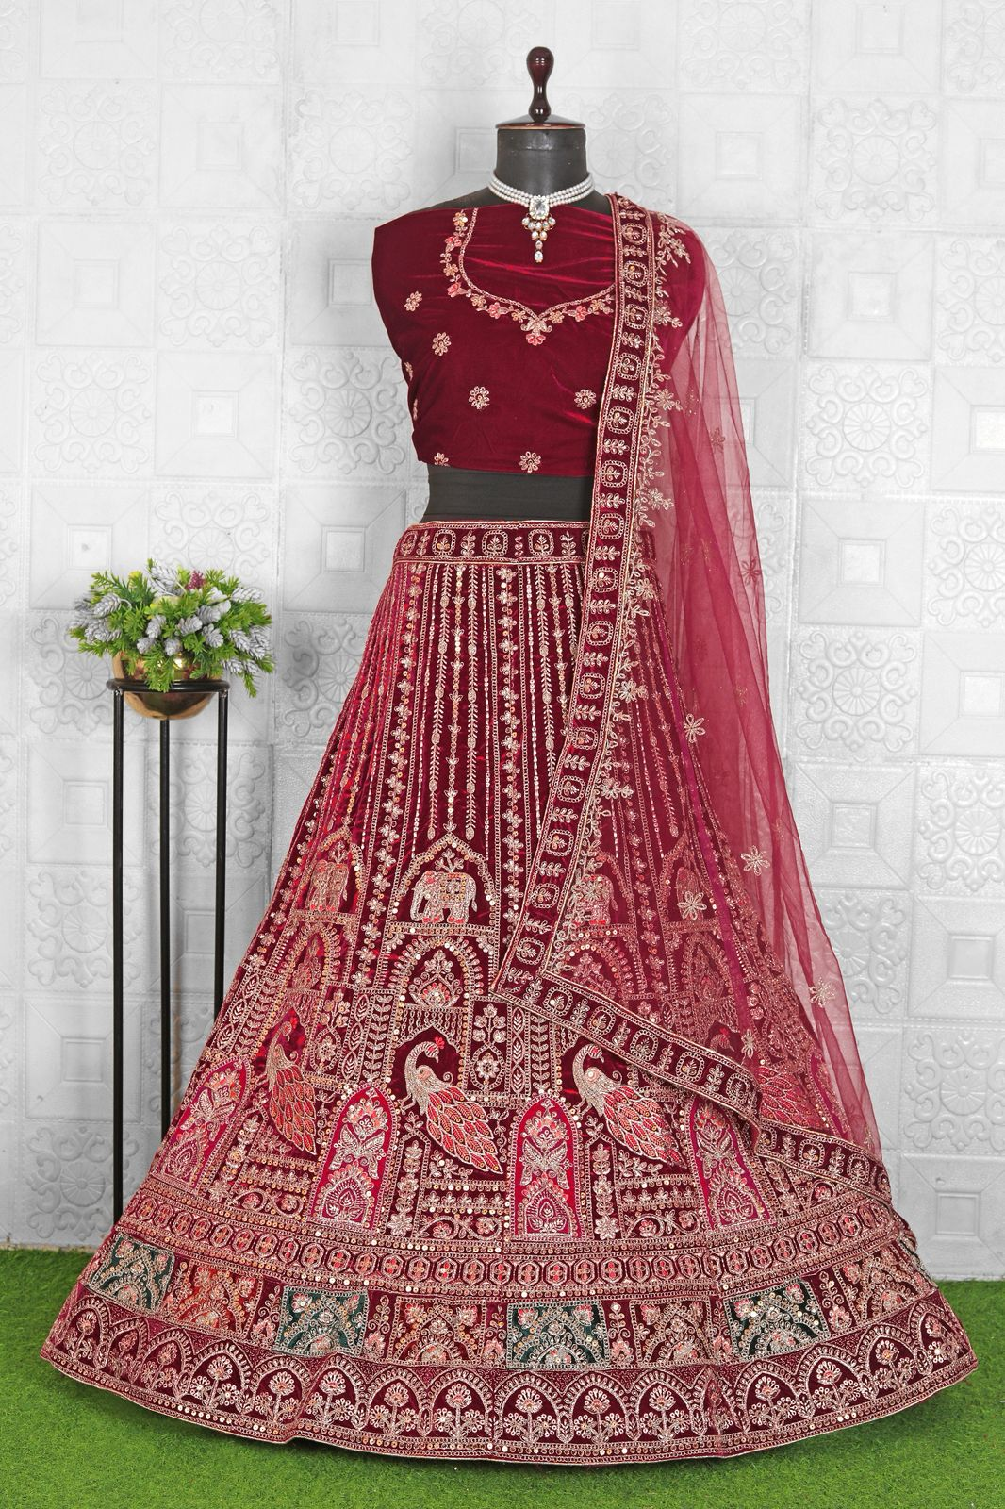
Particulars | Details
Lehenga Fabric | Premium Velvet
Blouse Fabric | Velvet with Embroidered Detailing
Dupatta Fabric | Net
Work Type | Heavy Zari
Colour | Light - Maroon
Pattern | Bridal Designer
Stitching Type | Semi-Stitched (Can be customized up to 44")
Occasion | Wedding, Reception, Engagement & Festive Wear
Fit Type | Regular Fit
Care Instructions | Dry Clean Only
Package Contents | 1 Lehenga, 1 Blouse Piece, 1 Dupatta

KEY HIGHLIGHTS
- Made from high-quality fabrics that offer a rich and luxurious feel
- Showcases intricate embroidery with exceptional attention to detail
- Comes with a coordinated blouse piece and dupatta for a complete bridal look
- Suitable for weddings, receptions, and high-end festive occasions
- Semi-stitched for effortless customization and a flawless fit
- Lightweight and comfortable for extended wear
- A perfect fusion of traditional craftsmanship and contemporary style

